WaPOR Biomass Production Validation Exercise
In this exercise, you will validate the WaPOR Biomass production data (or NPP) with observed yield data. For this exercise, you need a location (field or scheme) where you know the actual/estimated yield of a certain crop.
Task: Calculate the seasonal biomass production
- Calculate for the season (between start and end date) the total biomass production using the following equations:
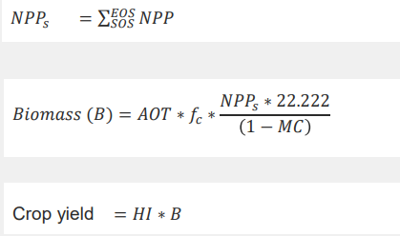
- The following parameters are needed to calculate the crop yield:
  - AOT = Above over total biomass production
  - f_{c} = Ratio of light use efficiency for a C3 crop (1.0) and for C4 crop (1.8)
  - MC = moisture content
  - HI = harvest index
Typical values for these parameters are provided in Annex 1
- Download from WaPOR the timeseries of NPP for the season for this location/area and add them up. Multiply the seasonal NPP using the equations above and compare with the observed data.

Annex 1 List of typical crop parameters.
Crop | Typical Harvest index | Range Harvest Index | Moisture content (harvestable product)
 | (-) | (-) | (Weight %)
Alfalfa
Banana | 0.6 |  | 76
Barley
Beans | 0.16 | 0.25 - 0.65 | 33
Cassava | 0.60 |  | 65
Coconut | 0.244 nut/kg |  | 0
Coffee
Cotton | 0.13 | 0.07 - 0.21 | 2
Eucalypt | 0.5 |  | 50
Grapes | 0.22 | 0.11 - 0.43 | 75
Grass | 0.45 | 0.40 - 0.55 | 60
Lucerne | 0.60
Maize - rainfed | 0.32 | 0.20 - 0.47 | 26
Maize - irrigated | 0.39 | 0.20 - 0.50 | 26
Mango | 0.14 |  | 84
Olives | 0.012 |  | 20
Onions | 0.55 |  | 85
Oranges | 0.22 | 15 - 35 | 85
Palm oil | 0.185 |  | 1
Pineapple
Potato | 0.80 | 0.75 to 0.85 | 78 - 82
Rice - rainfed | 0.33 | 0.20 - 0.50 | 14 - 19
Rice - irrigated | 0.42 | 0.20 - 0.55 | 14 - 19
Rubber | 0.013 |  | 63
Sorghum | 0.25 | 0.10 - 0.45
Soybean |  | 0.20 - 0.40
Sugarbeet | 0.60 |  | 80
Sugar cane | 0.69 | 0.65 - 0.85 | 65
Tapioca
Tea | 0.12 | 0.03 - 0.15 | 50
Wheat | 0.37 | 0.15 - 0.50 | 14 - 17

