**WaPOR Biomass Production Validation Exercise**

In this exercise, you will validate the WaPOR Biomass production data (or NPP) with observed yield data. For this exercise, you need a location (field or scheme) where you know the actual/estimated yield of a certain crop.

**Task: Calculate the seasonal biomass production**

* Calculate for the season (between start and end date) the total biomass production using the following equations:

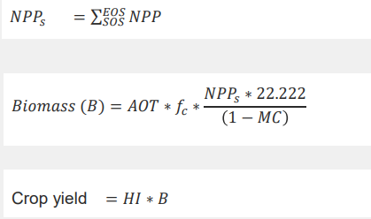

* The following parameters are needed to calculate the crop yield:
  + AOT = Above over total biomass production
  + *fc* = Ratio of light use efficiency for a C3 crop (1.0) and for C4 crop (1.8)
  + MC = moisture content
  + HI = harvest index

Typical values for these parameters are provided in Annex 1

* Download from WaPOR the timeseries of NPP for the season for this location/area and add them up. Multiply the seasonal NPP using the equations above and compare with the observed data.

## Annex 1 List of typical crop parameters.

|  |  |  |  |
| --- | --- | --- | --- |
| **Crop** | **Typical Harvest index** | **Range Harvest Index** | **Moisture content (harvestable product)** |
|  | **(-)** | **(-)** | **(Weight %)** |
| Alfalfa |  |  |  |
| Banana | 0.6 |  | 76 |
| Barley |  |  |  |
| Beans | 0.16 | 0.25 - 0.65 | 33 |
| Cassava | 0.60 |  | 65 |
| Coconut | 0.244 nut/kg |  | 0 |
| Coffee |  |  |  |
| Cotton | 0.13 | 0.07 - 0.21 | 2 |
| Eucalypt | 0.5 |  | 50 |
| Grapes | 0.22 | 0.11 - 0.43 | 75 |
| Grass | 0.45 | 0.40 - 0.55 | 60 |
| Lucerne | 0.60 |  |  |
| Maize - rainfed | 0.32 | 0.20 - 0.47 | 26 |
| Maize - irrigated | 0.39 | 0.20 - 0.50 | 26 |
| Mango | 0.14 |  | 84 |
| Olives | 0.012 |  | 20 |
| Onions | 0.55 |  | 85 |
| Oranges | 0.22 | 15 - 35 | 85 |
| Palm oil | 0.185 |  | 1 |
| Pineapple |  |  |  |
| Potato | 0.80 | 0.75 to 0.85 | 78 - 82 |
| Rice - rainfed | 0.33 | 0.20 - 0.50 | 14 - 19 |
| Rice - irrigated | 0.42 | 0.20 - 0.55 | 14 - 19 |
| Rubber | 0.013 |  | 63 |
| Sorghum | 0.25 | 0.10 - 0.45 |  |
| Soybean |  | 0.20 - 0.40 |  |
| Sugarbeet | 0.60 |  | 80 |
| Sugar cane | 0.69 | 0.65 - 0.85 | 65 |
| Tapioca |  |  |  |
| Tea | 0.12 | 0.03 - 0.15 | 50 |
| Wheat | 0.37 | 0.15 - 0.50 | 14 - 17 |