**WaPOR Biomass Production Validation Exercise**

In this exercise, you will validate the WaPOR Biomass production data (or NPP) with observed yield data. For this exercise, we use one field in Wonji sugarcane estate in Ethiopia (location lat 8.44, long 39.25).

**Task 1: Calculate the seasonal biomass production**

* Calculate for the season starting 2017/02 and ending 2018/2 the total biomass production using the following equations:

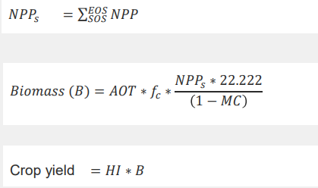

* For sugarcane the following parameters can be used
* Above over total biomass production (AOT) = 1.0
* Ratio of light use efficiency for C4 crop (*fc*) = 1.8
* moisture content (MC) = 0.59
* harvest index (HI) = 0.65
* Download from WaPOR the timeseries of NPP for the season for this location and add them up. Multiply the seasonal NPP using the equations above. Answer the following question:

The farm manager states that the annual yield in Wonji estate is around 100 ton/ha, is this field an above or below average performing field?

**Task 2: Repeat task one with crop type data from West Gharraf crops**

* Select a number of sites with known crop types and season
* Download from WaPOR the timeseries of NPP for the season and add them up. Multiply the seasonal NPP using the equations above. Answer the following question:

Are the yield estimations in the line of expectation or are they higher or lower than expected?

NOTE: based on the crop types found in the field, the lecturers will provide the parameter values