

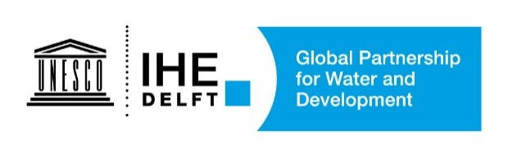

WEF Nexus assessment: a Guidance for Case Studies.
Getting started, and mapping and understanding the nexus issues

Janez Sušnik (IHE Delft), Sara Masia (IHE Delft), Graham Jewitt (IHE Delft)

1. Introduction

As case study leaders/main contact points, you have a critical role in helping to shape the direction of the research and therefore the outcomes for your case study. In order to guide you in framing and developing your case study, this document offers a guide to getting starting: what is the process, what steps need to be taken, actors to include, and initial outcomes. The aim of this first stage is to understand and conceptualise your case study in order to better understand the local nexus context: what are the focal nexus areas of interest; how the local nexus system ‘work’ (i.e. how do elements and sectors relate to each other); what are your ambitions for the work and; what data /information can be available; what indicator outputs would be most beneficial to you.

At any time, help and support is available from either Dr. Janez Sušnik (j.susnik@un-ihe.org) or Dr. Sara Masia (s.masia@un-ihe.org).

Much of what is written in this document is taken from extensive experience of a very similar process in the ongoing (2016-2020) EC H2020 project SIM4NEXUS (www.sim4nexus.eu). Where possible, examples from SIM4NEXUS are used to illustrate potential outcomes at each stage.

2. Getting started: mapping the nexus, identifying key issues, data, and stakeholders

The process for this first stage of the work is relatively simple on paper. However due to the iterative nature of the process, and the many stakeholders potentially involved, it can become quite involved. Because of how important it is in guiding future research in the case study, the importance of this stage should not be underestimated.

2.1 Initial draft nexus system conceptual maps
The first step is to draft a very first ‘sketch’ or ‘map’ of the local nexus system for which the case study is concerned, which is the main output at this stage. This map can be as simple as sketch on paper, but could include:
- the main nexus sectors of concern for the case study;
- how they interact with each other (i.e. the mechanism by which they interact);
- driving forces (either on individual sectors, or on the nexus as a whole);
- which policies/management decisions either do, or in the future may, affect production and consumption in each sector;
- where data may be available or missing, and;
- which stakeholders are interested in each of the sectors.

This initial step may not take very long, but is important for further case study and research development, and will be used as a basis on which much future work is based. Some examples of possible first-round outputs of nexus systems maps are shown. In Figure 1, the first map of the nexus system in the Andalusia case in SIM4NEXUS is shown. Sticky paper notes are used to make moving different nexus elements around straightforward. Lines between elements indicate some form of connection between the two. While this particular example was in fact produced with wider stakeholder involvement, a similar approach could be adopted in a smaller setting without stakeholders to produce a first draft. From this initial map, a neater version was drafted that captured the main elements from Figure 1 (Figure 2). As can be seen from Figure 2, this map is at a high-level, indicating all the major nexus sectors (water, energy, food, land, and climate), with little additional elaboration. The direction of the arrows denote connection or influence between sectors, and some arrows are labelled with possible mechanisms linking different sectors. Potential data sources (indicated by ‘E3ME’ and ‘CAPRI’ in the lower right of the figure) are tentatively identified. Similarly, Figures 3-5 show first draft system maps for the Netherlands, Sweden, and Latvian case studies respectively. As with the Andalusian example, these are all high-level, showing all the main nexus sectors (with the exception of Sweden, where slightly more information is added), the main connections between the sectors, including potential mechanisms of the connections, and potential data sources. In some cases (e.g. Netherlands and Latvia), the first-draft maps were very similar, though they diverged later in the project.

Figure 1: example nexus system map from the Andalusia case study in SIM4NEXUS (Brouwer and Fournier, 2017).

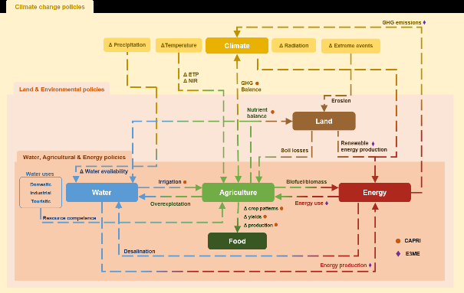
Figure 2: first draft map of the nexus system in Andalusia in SIM4NEXUS (Brouwer and Fournier, 2017).

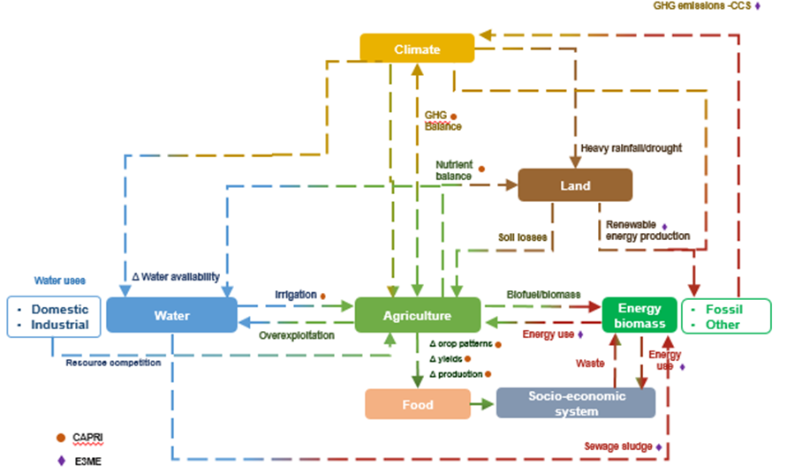
Figure 3: first draft nexus map for the Netherlands case study in SIM4NEXUS (Brouwer and Fournier, 2017).

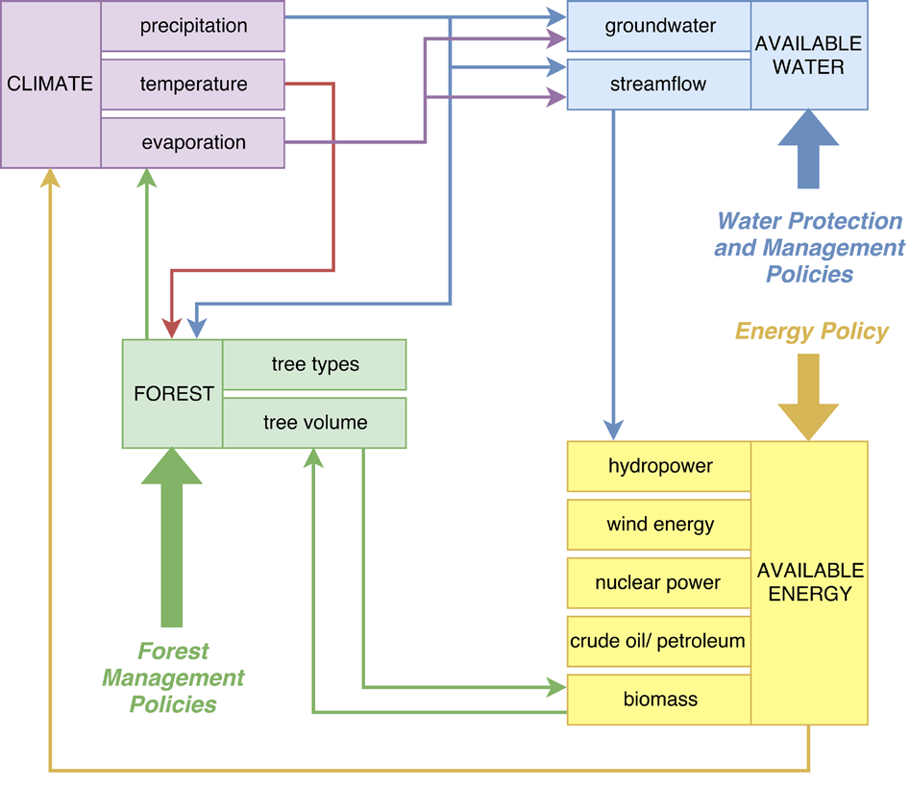
Figure 4: first draft nexus map for the Sweden case study in SIM4NEXUS (Brouwer and Fournier, 2017).
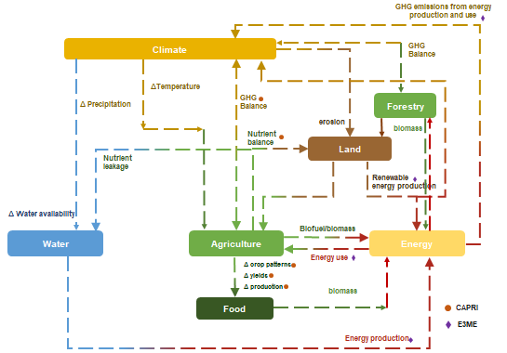
Figure 5: first draft nexus map for the Latvia case study in SIM4NEXUS (Brouwer and Fournier, 2017).

In this drafts it could be useful a first attempt to identify stakeholders relevant for each sector and possible policies influencing the sectors. Identification of potential stakeholders is important for the next step, while identifying policies or other ‘system alteration mechanisms’ is important for analysis later in the research. The first draft could also include a first attempt to identify SDGs which could be addressed through the analysis in the case study.
Ultimately, the first draft should be a relatively simple, high-level understanding of the local nexus for your case study on which further detail and elaboration can be added. Section 2.3 gives examples of more detailed system maps produced after many rounds of iteration.

2.2 Grounding the nexus: the involvement of stakeholders
It is apparent that in order to achieve on-the-ground impact, the continued involvement and engagement of local, interested stakeholders from a variety of backgrounds is essential. It is therefore critical to identify and engage stakeholders as early on as possible in the project. Case study owners should be well placed to carry out a stakeholder mapping exercise to determine key parties to approach.
The draft nexus maps can form an entry point to the stakeholder mapping. First, each actors in each sector (water, energy, food, climate, and land) can be identified and approached. From that, stakeholders with a wider interest in the nexus can also be identified. For example Ministries concerned with planning or river basin organisations may be interested in more than one sector, and be interested to better understand how to optimise management and policy formulation. Stakeholders should, if possible, also include actors from policy and governance, academia, industry and NGOs in order to garner as wide a set of viewpoints and ideas as possible.
Once a broad set of stakeholders is identified, it is suggested to hold a joint stakeholder workshop as soon as possible in which the project is explained in general terms, and then the initial nexus mapped is analysed, discussed and edit to update and include stakeholder views. Sectors may shift in importance, detail can be added to each sector as well as to the processes operating between the sectors, and first ideas of how to measure and monitor changes in each sectors (i.e. indicators) may come up. For example, one workshop aim could be to draft system maps for each nexus sector, together with the links to other sectors, and the mechanism behind those links. This would lead to a ‘nested model’ of the nexus, similar to a Russian doll: the highest level (the main nexus sectors) and be ‘opened up’. Each sector can then be explored in more detail. This concept is further explained in the next section. Stakeholders can also indicate where data may be available. Particular stakeholder groups can also help to indicate the policies relevant for the nexus under study, and in which sector they may be operational. Additional policy detail could include the mechanism by which the policy is implemented, how long the policy is due to last, and the main objectives of those policies.
Following the workshop, regular updating of stakeholders as to project progress and offering new draft of the system map is essential. Firstly, it helps to keep them engaged through the project life. But more importantly, they can track what is going on and what is behind any models that may ultimately be developed. By understanding the basis from which models and indicators are developed, more trust and understanding is placed on results. This leads to more intuitive interpretation of outputs, making them more likely to be utilised in practice.

2.3 Iterating and finalising the system maps
Following from the stakeholder event, the extra detail and information gathered can be used to update the initial nexus maps (via a series of iterations) with more detailed representations of each sector, potential data sources, and where and how policy may impact on the nexus. Examples of final nexus conceptual maps from SIM4NEXUS are used here as illustrative examples of the kind of output that can be achieved.
Figures 6 to 11 illustrate the final conceptual model for the SIM4NEXUS Netherlands case study. The ‘top-level’ of the system (Figure 6) is similar to that in Figure 3 in that it shows the main nexus sectors, the interactions between them, likely mechanisms representing those interactions, and potential data sources from various models (noted as MAGNET, CAPRI and E3ME), although local data sources or open databases could also be included. Feedbacks are indicated at level, for example there is a two-way arrows between water and agriculture, indicating that water is used in the production of agricultural goods, and that agriculture impacts the water sector, largely by exploiting the resource and by altering the quality of the resource. Each sector is subsequently mapped in much more detail than in the first draft after consultation with a stakeholder group. The energy sector is shown in Figure 7, agriculture in Figure 8, water in Figure 9, land in Figure 10, and the socio-economic system in Figure 11. Taking energy as an example, this sector is now outlined in considerable detail, indicating the emphasis is likely to be placed on this in further quantitative model development and in the output indicators desired. Numerous primary energy sources are indicated (e.g. coal, oil, wind, solar) which are then transformed into secondary energy sources (e.g. heat, electricity, fuels). This energy is consumed by sectors in the socio-economic system (e.g. transport, housing). Connections to other nexus sectors are also indicated, reflecting the same links in Figure 6. There is a link from energy production to water, indicating that producing energy indeed requires water resources. A link to land indicates that land resources are required for the growth of bioenergy crops. The link to the climate sector is highlighted, aiming to quantify the climate impact of energy generation. The other sectors (Figures 8-11) are similarly detailed, also showing connections to the other nexus sectors. In this way, a detailed map of the entire system is drawn.
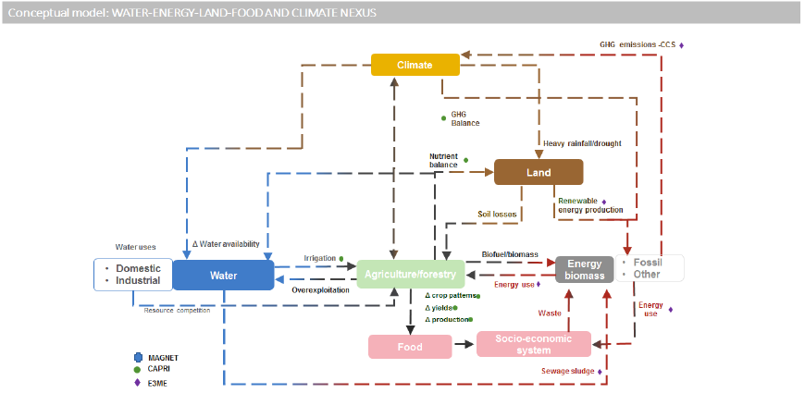
Figure 6: ‘top-level’ nexus conceptual map for the Netherlands case study in SIM4NEXUS (Vamvakeridou-Lyroudia et al. 2019).

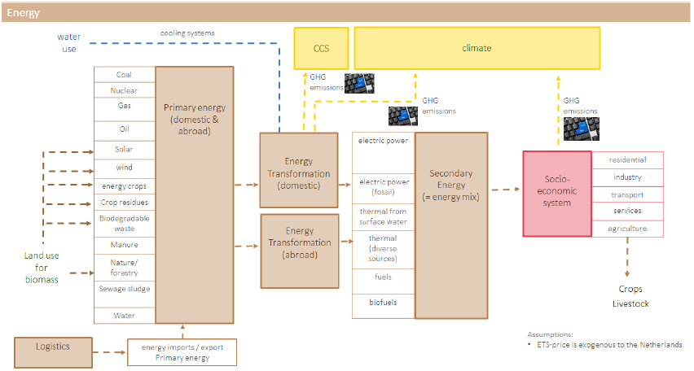
Figure 7: the conceptual map for the energy part of the nexus system in the Netherlands case study of SIM4NEXUS (Vamvakeridou-Lyroudia et al. 2019).

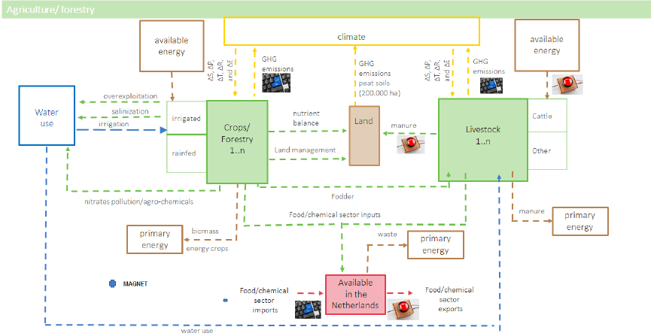
Figure 8: the conceptual map for the agricultural part of the nexus system in the Netherlands case study of SIM4NEXUS (Vamvakeridou-Lyroudia et al. 2019).

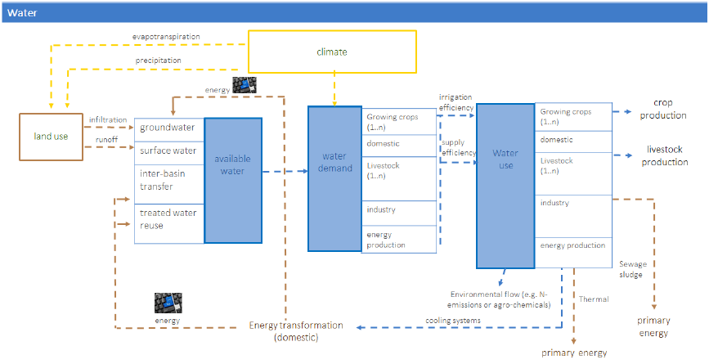
Figure 9: the conceptual map for the water part of the nexus system in the Netherlands case study of SIM4NEXUS (Vamvakeridou-Lyroudia et al. 2019).

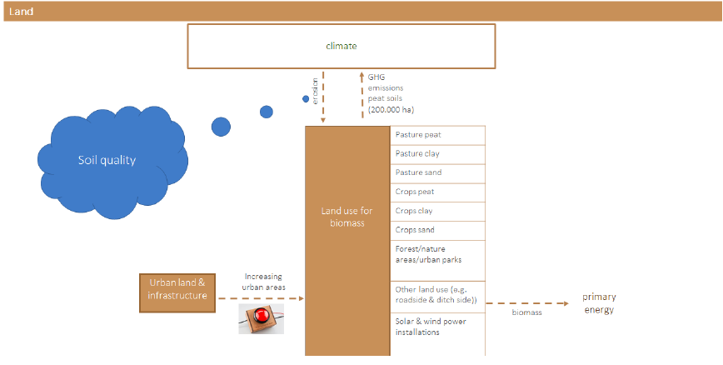
Figure 10: the conceptual map for the land part of the nexus system in the Netherlands case study of SIM4NEXUS (Vamvakeridou-Lyroudia et al. 2019).

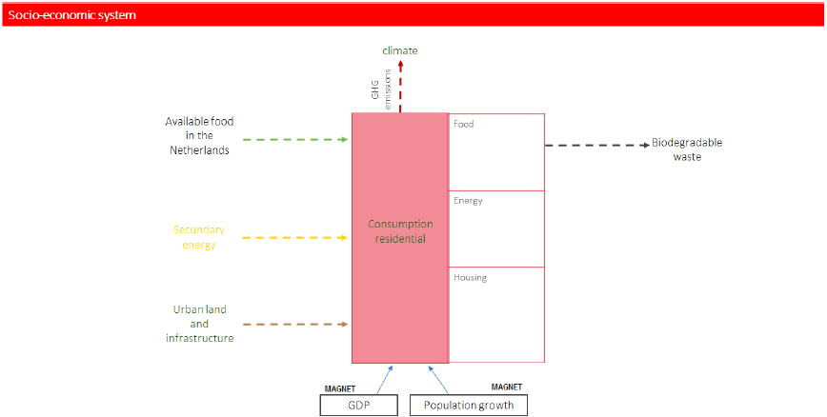
Figure 11: the conceptual map for the socio-economic part of the nexus system in the Netherlands case study of SIM4NEXUS (Vamvakeridou-Lyroudia et al. 2019).

One main item that was generally not included in the SIM4NEXUS conceptual models is, with the help of stakeholders, to indicate where in the nexus various policy measures and/or objectives might influence the system. This could be as simple as a tentative indication of a potential policy intervention (e.g. Figure 10), or could be as detailed as annotating the policy document, aim, objective and measure by which it is implemented. While this is not essential, it could help at later modelling stages to determine where and how the nexus is to be altered for forecasting and decision-making. In the Netherlands examples, red buttons (e.g. in Figure 10) and ‘keyboards’ (e.g. in Figure 9) indicate where policy might be implemented and which variables might be altered respectively in future modelling exercises.
Creating such detailed system maps can be time consuming. However careful thought is required in order to place emphasis on critical system sectors, so that future work is focussed on the most pertinent issues for the case study. Likewise, an early scoping of data and policies is useful for case study framing and to guide further research as the project progresses.

2.4 Towards case study framing and output: tentative description of output indicators
Once the nexus system has been framed and conceptualised, and data sources/requirements, nexus linkages and policies have been at least initially identified, initial thought can be given as to what the case study owners and interested stakeholders would value as output indicators, metrics, and results. Because the main issues are identified, emphasis can be placed here. For example, for some places, the main criteria to track may be the long-term trend of water stored in reservoirs and the potential impacts of such trends on availability for other uses (e.g. agriculture or domestic supply). Other case studies might instead place emphasis on the potential climate impact of implementing various policy objectives such as a drive towards an increase of growing crops for the production of biofuels.
Starting to think about relevant nexus-wide indicators or metrics that are understandable and intuitive is important for generating meaning impact from the work. Related to this therefore is the need to think about what data and other information might be needed in order to arrive at the desired index/metric/number/assessment, and which stakeholder input might be necessary. In order to help and to give first ideas of possible nexus indicators, there is literature to guide case studies (e.g. Conway et al. 2015, Steffan et al. 2015; World Bank, 2016; OECD, 2017; Dao et al. 2018; Carmona-Moreno et al. 2019; Simpson et al. 2019).

3. Summary and next steps

To summarise, the first steps should be to getter a better appreciate of the main nexus issues in the case studies, and to ‘map’ the main issues of concern for the study. An effective way to do this, with the inclusion of stakeholders, is to develop conceptual maps of the nexus system in order to start to understand dependences, critical interlinkages, data needs, stakeholder interest groups, policy intervention areas, and potential outputs. There are four main phases to this initial stage:
- drafting first-versions of nexus system conceptual maps;
- identification and early engagement of stakeholders;
- refinement and finalisation of system conceptual maps, with identification of stakeholder interests, data, and policy interventions that may be important to consider;
- with a better understanding the system and aims for the case study, start thinking about output indicators, metrics and values to be able to assess impact to the system and the state of the system.

This initial phase is essential for future development of robust quantitative nexus models to be able to assess the potential impact of policy interventions or other changes to nexus system sectors on the entire nexus, with the results being reported in intuitive, understandable indicators or metrics. The models will aim to ‘translate’ the conceptual maps as accurately as possible within data limitations. The models can then be adjusted to represent the implementation of a policy or a shock to the system, and the whole system response can then be observed. As with this first exercise, engagement of stakeholders is key to ensuring their continual understanding and support, leading to a greater chance of higher impact output.

4. Acknowledgements

We gratefully acknowledge the EC H2020 project “SIM4NEXUS” (www.sim4nexus.eu) for permission to use example materials derived from research carried out in the project. This report was funded by DUPC2, the programmatic cooperation between the Directorate-General for International Cooperation of the Dutch Ministry of Foreign Affairs and IHE Delft Institute for Water Education in the period 2016-2020.

8. References

Brouwer F., Fournier M. 2017. D5.2: The main nexus challenges in 12 Case Studies. SIM4NEXUS Deliverable 5.2. Available at: www.sim4nexus.eu/userfiles/Deliverables/Deliverable%20D5.2.pdf

Carmona-Moreno C., Dondeynaz C., Biedler M. (Editors). 2019. Position Paper on Water, Energy, Food, and Ecosystem (WEFE) Nexus and Sustainable development Goals (SDGs). EUR 29509 EN, Publications Office of the European Union, Luxembourg. ISBN 978-92-79-98276-7. DOI: 10.2760/5295, JRC114177

Conway D., van Garderen EA., Deryng D., Dorling S., Krueger T., Landham W, Lankford B., Lebek K., Osborn T., Ringler C., Thurlow J., Zhu T., Dalin C. 2015. Climate and southern Africa’s water-energy-food nexus. Nature Climate Change. 5: 837-846. DOI: 10.1038/NCLIMATE2735

Dao H., Peduzzi P., Friot. 2018. National environmental limits and footprints based on the Planetary Boundaries framework: The case of Switzerland. Global Environmental Change. 52: 49-57. DOI: 10.1016/j.gloenvcha.2018.06.005

OECD. 2017. The land-water-energy nexus: Biophysical and economic consequences. OECD Publishing, Paris. DOI: 10.1787/9789264279360-en

Simpson GB., Badenhorst J., Jewitt GPW., Berchner M., Davies E. 2019. Competition for land: the water-energy-food nexus and coal mining in Mpumalanga Province, South Africa. Frontiers in Environmental Science. 7: 86. DOI: 10.3389/fenvs.2019.00086

Steffan W., Richardson K., Rockstrom J., Cornell SE., Fetzer I., Bennett EM., Biggs R., Carpenter SR., de Vries W., de Wit CA., Folke C., Gerten D., Henike J., Mace GM., Persson LM., Ramanathan V., Reyers B., Sorlin S. 2015. Planetary boundaries: Guiding human development on a changing planet. Science. 347: 1259855. DOI: 10.1126/science.1259855

Vamvakeridou-Lyroudia LS., Sušnik J., Masia S., Indriksone D., Bremere I., Polman N., Levin-Koopman J., Linderhof V., Blicharska M., Teutschbein C., Mereu S., Trabucco A., Castro B., Martinez P., Blanco M., Avgerinopoulos G., Laspidou C., Mellios N., Ioannou A., Kofinas D., Papadopoulou C.-A., Papadopoulou M., Conradt T., Bodirsky B., Pokorný J., Hesslerová P., Kravčík M., Griffey M., Ward B., Evans B., Hole N., Khoury M., Petersen C., Fournier M., Janse J., Doelman J. 2019. D3.4: Final report on the complexity science and integration methodologies. SIM4NEXUS Deliverable 3.4. Available at: https://www.sim4nexus.eu/page.php?wert=Deliverables

World Bank. 2016. High and Dry: Climate change, water and the economy. World Bank, Washington, D.C.

