A solar-powered private smallholder irrigation along Shashi and Shashane sand rivers in southern Zimbabwe (Limpopo river basin)

Background

Global projections indicate that demand for freshwater, energy and food will increase significantly over the next decades under the pressure of population growth and mobility, economic development, international trade, urbanisation, diversifying diets, cultural and technological changes, and climate change (Hoff, 2011). Globally, smallholder irrigation systems have gained increasing attention as they are viewed as critical mechanisms that are needed to improve food security and sustain livelihoods in marginalised semi-arid regions (Duker et al., 2020b). Improving agriculture and intensifying productivity through smallholder irrigation is one of the key strategies for alleviating poverty and improving the livelihoods of rural communities; the majority of the poor depend directly or indirectly on agriculture. This is particularly the case of Zimbabwe, where approximately 80% of agricultural land lies in arid or semi-arid regions (Svubure et al., 2011). Rainfall in these regions is too erratic and unreliable for dryland farming, making supplementary irrigation necessary for successful agriculture. Regardless of state-level interests in larger-scale and more modern systems of food production, small-scale farmers continue to comprise a substantial proportion of the population and are responsible for much of the crop production in many developing countries.
Food production requires energy and water in many stages of the food system. The small-scale farmers in the Limpopo River Basin (LRB) rely on water from sand rivers for irrigating their fields (Mansell and Hussey, 2005). Sand rivers are ephemeral watercourses containing sand, which flow once or a few times in a year (Mpala et al., 2020). Although no water flows in the river bed for most of the year, there is perennial groundwater flow within the sand (Love et al., 2011). They have been used by rural communities for domestic and smallholder crop production purposes for centuries. Recently, farmers have adapted to abstract water from sand rivers using small diesel or petrol pumps allowing small commercial agriculture enterprises to develop. There is a now a shift towards solar powered pumps.
In Zimbabwe, particularly in Limpopo River catchment, sand rivers are acknowledged as a valuable source of drinking and irrigation water, although their use in commercial agriculture is still in a rudimentary phase (Duker et al., 2020a). In the Tsheyalenyemba area (Figure 1), smallholder farmers, mostly informal, depend on water from sand rivers for crop irrigation. The sand abstraction water supply systems in the Tsheyalenyemba area have water of reasonable quality and can adequately meet the per capita human daily water requirements of the smallholder farmers. Although manual installation of well points in or close to the river bed is straightforward and feasible, extracting this water has some challenges. The farmers need to invest in technology and mobilise energy, which has been found extremely hard in this economically marginalised region in a country that has been hit by economic crisis for several decades. However, these farmers have strong adaptive capacity and are withstanding these socio-economic and climatic shocks through different strategies. One of these is that farmers in this area are now using solar energy powered pumps to abstract water from sand rivers.
The main aim of the Limpopo river basin case study is to reduce poverty, improve human livelihoods by irrigating crops using water from sand rivers. Farmers are moving from the rainfed croplands to the irrigation schemes where they can have different sources of livelihoods including fishing, crop production and livestock keeping. This is having a positive impact on socio-economic development and the quality of life thanks to the possibility of increasing income and employment. Although this migration is having benefits for the basin`s population, there are also important trade-offs to consider.
Case study description
The LRB covers the Shashe and Shashani rivers, both located in the Matabeleland South Province on southwestern Zimbabwe (Figure 1). The two rivers were chosen as they are currently sustaining small-scale sand water abstraction systems installed by an NGO i.e. the Dabane Trust. The Shashe River is a major left-bank tributary of the Limpopo River in Zimbabwe and flows into the Limpopo River where Botswana, Zimbabwe and South Africa meet. The river flows in both Zimbabwe and Botswana; it is 330 km long from its source to mouth, 210 km of which are in Zimbabwe and 120 km in Botswana, and its total catchment area is 24,585 km². The Shashani River is a major tributary of the Shashe River. It flows for about 206 km and is dammed at two locations.
Recently the basin has started practicing small scale (0.1 – 1 ha) commercial agriculture using water from the sand rivers. A significant number of families live in the basin and are largely responsible for their own economic and social sustainability. Currently, the basin is facing rapid emigration of men in the age group of between 20 and 45 years to South Africa and Botswana. Women and children are left behind. Small holder irrigation using the water from sand rivers can boost their livelihoods.
Some of the expected outcomes upon successful execution of the LRB are:
- Increased water availability and accessibility production to facilitate the development of Small and Medium farmers and improve food production and livelihoods in the basin;
- Increased food production through irrigated agriculture (a benefit for at least 500 farm families);
- Increased access to water supply and sanitation in the basin (more than 50,000 people by 2030);
- Increased water availability to improve water access during droughts;
- Socio-economic improvement of the Limpopo river basin inhabitants (people are using their profits from selling farm produce to improve their livelihoods by building descent accommodation, sending children to school)
- Mitigation of drought (more than 100,000 people will be relieved);
- Small-scale fisheries activities to enhance protein intake and provide an alternative source of income to the inhabitants;
- Sustainable management of the Limpopo River Basin;
- Improved management information system through water resources monitoring, development and management;
- Enhanced cooperation between catchments and sub-catchments.”
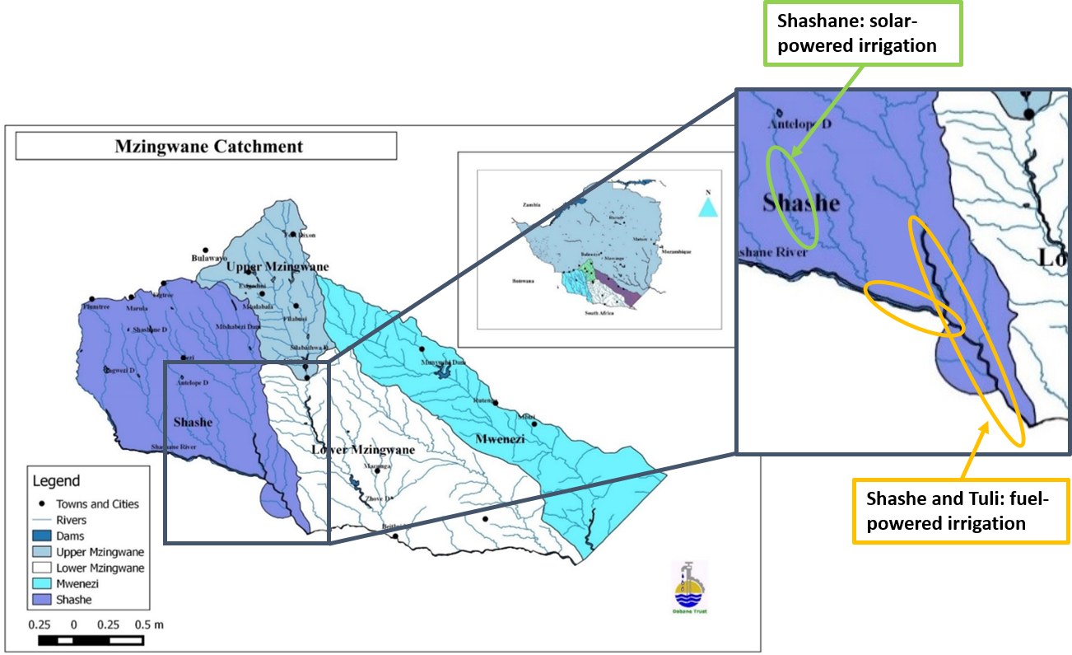
Figure 1 Map of the study area showing the Shashe and Shashani catchment in the Limpopo River Basin.

The main challenges in Limpopo River Basin and the potential impact of the LRB Programme
Climate change is predicted to magnify annual precipitation received in the LRB. This will further threaten water availability and timing in the Limpopo river basin, reducing accessible and available water for human usage, agriculture, and sanitation. The installation of solar panels and solar powered pumps is vital to ensuring water, food, and energy security. Changes in the frequency and severity of drought are predicted to have a considerable influence on the socioeconomic system, inflicting damage to built-up regions and cultivated land.
Water access and availability are major challenges in the basin; in fact, not everyone has access to clean water, and methods of increasing supply are being investigated. Access to essential water needs and agricultural supplies is limited. Because of inadequate water supply, WHO-recommended prophylactic measures during the Covid-19 pandemic may not always be implemented, thereby affecting human health and the socioeconomic system. The installation of water pumps is intended to play a critical role in enhancing alluvial water accessibility and water supply, especially in the context of climate change. Changes in precipitation frequency and intensity may have an impact on available water, resulting in unavoidable imbalances between water supply and demand, as well as an inescapable impact on the socioeconomic system and the land sector, and hence on local food production. Because of the tremendous need for water and energy, the food sector is one of the most prominent in the basin. The small irrigation schemes, as well as the installation of more than 50 solar power pumps and a number of solar panels, are planned to enhance irrigated area in the basin over the next decade, ensuring water, energy, and food security.
Food security is also predicted to benefit from increased small-scale fishing activity, which has been identified as one of the LRB's primary outputs. Diversification of locally produced food available for consumption is critical for dealing with nutrition difficulties and food-borne infections.
Several issues, including a lack of arable land, falling soil fertility, and climate change, have recently hampered the agricultural sector. To deal with these challenges, farmers are shifting from rainfed agriculture to irrigation and livestock production, where they may earn a living through fishing, agricultural production, and livestock husbandry. Because of the potential for increased income and employment, this has a favourable impact on socioeconomic development and quality of life. Although this shift improves the basin's population, there are significant trade-offs to consider. In fact, despite the fact that crop production is quickly expanding due to increased food need, cultivation of these lands is uncontrolled. This rapid land use change, along with a lack of measurements, is having a significant influence on socioeconomic activity and local people's livelihoods. Indeed, while the increase of arable land generates more revenue, rapid and unregulated land use change undermines other forms of livelihood and contributes considerably to biodiversity loss and ecosystem health (Logan, 2020). Natural flora has been lost as a result of resource overexploitation, and permanent wet regions have vanished. The conversion of grasslands and forested areas to agricultural land is now one of the primary reasons of desertification, erosion and extinction of fauna and flora species (Kerley et al., 1995). Another significant issue is the lack of access to food, which is compromised by a lack of services, particularly access to markets and roads. As a result, the LRB includes road improvements, which are projected to improve food accessibility and availability. In the food balance, it is critical to include both local food produced and eaten, as well as food preserved and sold, for their impact on the socioeconomic system in terms of market, food price, food diversity, and dietary changes.
Although the LRB projects are predicted to have a favourable influence on water, energy, and food availability and accessibility, irrigated land, food diversity, revenue production, and human health, there are also expected to be drawbacks. Indeed, increased crop production (particularly farmland and river bank cultivation) may have a significant influence on water quality due to increased nutrient and pesticide loads in the river. This could have a negative impact on human and ecological health. Increased agricultural activity can result in pollution, biodiversity loss, provision of ecosystem goods and services, land degradation, and soil fertility (Logan, 2020, Mpala et al., 2016).
Identifying interconnections, synergies, and trade-offs across the sectors and sub-sectors that will be touched by the LRB is critical for assessing the Program's potential impact on the basin and better addressing decision-making. The LRB Programme's key challenges are to reduce poverty, promote human health and livelihoods, assure water, food, and energy security, reduce natural climate variability and associated droughts, and improve sustainable river basin management. Cooperation between relevant stakeholders is very necessary in order to accomplish the goals of the Programme envisioned in the basin by all the involved stakeholders and to ensure the basin's sustainable development.
In order to solve the key challenges in the LRB, the government established a local river basin management authority (interim name only) in 2015. The authority “affirmed its determination to continue cooperating and promoting in a constructive and mutually beneficial manner in the sustainable development, utilization, conservation, and management of the Limpopo River Basin water and related resources for social and economic development, navigational and non-navigational purposes, and the well-being of locals, consistent with the needs to protect the environment.”(Duker et al., 2020).
Two important lessons were drawn from the 2021 workshop on water energy, food nexus in the river basin: "Equitable water allocation is not simple or straightforward." As a drought prone region water demand grows, so does the complexity of water allocation and management", and ii) "Allocations between crop irrigation and domestic water use has to be observed and documented."
The WEF nexus study may provide information regarding the state of the basin's nexus system. The nexus strategy can be used with local experts and stakeholders (e.g., Limpopo river basin local management authority ((interim name only), Ministries, international enterprises, private and public sectors) in mind. The nexus approach can be used while keeping in mind the importance of local experts and stakeholders (e.g., Limpopo river basin local management authority, Ministries, private and public companies, NGOs, academia, local farmers, and so on) in co-developing, testing, validating, and refining the WEF nexus analysis through an interactive collaboration. The LRB nexus assessment may aid decision-making, resulting in the development of short-, medium-, and long-term strategies for sustainable integrated resource management in the basin and others with similar features.

References
DUKER, A., CAMBAZA, C., SAVECA, P., PONGUANE, S., MAWOYO, T., HULSHOF, M., NKOMO, L., HUSSEY, S., VAN DEN POL, B. & VUIK, R. 2020a. Using nature-based water storage for smallholder irrigated agriculture in African drylands: Lessons from frugal innovation pilots in Mozambique and Zimbabwe. Environmental Science & Policy, 107, 1-6.
DUKER, A., MAWOYO, T., BOLDING, A., DE FRAITURE, C. & VAN DER ZAAG, P. 2020b. Shifting or drifting? The crisis-driven advancement and failure of private smallholder irrigation from sand river aquifers in southern arid Zimbabwe. Agricultural Water Management, 241, 106342.
HOFF, H. 2011. Understanding the nexus.
LOVE, D., VAN DER ZAAG, P., UHLENBROOK, S. & OWEN, R. 2011. A water balance modelling approach to optimising the use of water resources in ephemeral sand rivers. River research and applications, 27, 908-925.
KERLEY, G. I., KNIGHT, M. H. & DE KOCK, M. 1995. Desertification of subtropical thicket in the Eastern Cape, South Africa: are there alternatives? Environmental Monitoring and Assessment, 37, 211-230.
LOGAN, T. J. 2020. Sustainable agriculture and water quality. Sustainable agricultural systems. CRC Press.
MANSELL, M. & HUSSEY, S. 2005. An investigation of flows and losses within the alluvial sands of ephemeral rivers in Zimbabwe. Journal of Hydrology, 314, 192-203.
MPALA, S. C., GAGNON, A. S., MANSELL, M. G. & HUSSEY, S. W. 2016. The hydrology of sand rivers in Zimbabwe and the use of remote sensing to assess their level of saturation. Physics and Chemistry of the Earth, Parts A/B/C, 93, 24-36.
MPALA, S. C., GAGNON, A. S., MANSELL, M. G. & HUSSEY, S. W. 2020. Modelling the water level of the alluvial aquifer of an ephemeral river in south-western Zimbabwe. Hydrological Sciences Journal, 65, 1399-1415.
SVUBURE, O., GUMBO, T., SOROPA, G., RUSERE, F., NDEKETEYA, A. & MOYO, D. 2011. Evaluation of the Sand Abstraction Systems for Rural Water Supply: the case of Lupane District, Zimbabwe. International Journal of Engineering Science and Technology (IJEST), 3, 757-765.
WALKER, D., JOVANOVIC, N., BUGAN, R., ABIYE, T., DU PREEZ, D., PARKIN, G. & GOWING, J. 2018. Alluvial aquifer characterisation and resource assessment of the Molototsi sand river, Limpopo, South Africa. Journal of Hydrology: Regional Studies, 19, 177-192.

