Title: Water-energy-food (WEF) nexus for solar-powered private smallholder irrigation along Shashi and Shashane sand rivers in southern Zimbabwe
Tsitsi Bangira¹, Sara Masia², Janez Susnik², Graham Jewitt² and Tafadzwa Mabhaudhi ^{1,3}
¹ Centre for Transformative Agriculture and Food Systems, University of KwaZulu-Natal, P.
Bag X01, Pietermaritzburg, 3209, South Africa
² Integrated Water Systems and Governance Department, IHE Delft Institute for Water Education, PO Box 3015, 2601DA, Delft, the Netherlands
³ International Water Management Institute (IWMI), Pretoria, South Africa

Background

Globally, smallholder irrigation systems have gained increasing attention as they are viewed as critical mechanisms that are needed to improve food security and sustain livelihoods in marginalised semi-arid regions (Duker et al., 2020b). Improving agriculture and intensifying productivity through smallholder irrigation is one of the key strategies for alleviating poverty and improving the livelihoods of rural communities; the majority of the poor depend directly or indirectly on agriculture. This is particularly the case of Zimbabwe, where approximately 80% of agricultural land lies in arid or semi-arid regions (Svubure et al., 2011). Rainfall in these regions is too erratic and unreliable for dryland farming, making supplementary irrigation necessary for successful agriculture. Regardless of state-level interests in larger-scale and more modern systems of food production, small-scale farmers continue to comprise a substantial proportion of the population and are responsible for much of the crop production in many developing countries.
Food production requires energy and water in many stages of the food system. The small-scale farmers in the Limpopo River Basin (LRB) rely on water from sand rivers for irrigating their fields (Mansell and Hussey, 2005). Sand rivers are ephemeral watercourses containing sand, which flow once or a few times in a year (Mpala et al., 2020). Although no water flows in the river bed for most of the year, there is perennial groundwater flow within the sand (Love et al., 2011). They have been used by rural communities for domestic and smallholder crop production purposes for centuries. Recently, farmers have adapted to abstract water from sand rivers using small diesel or petrol pumps allowing small commercial agriculture enterprises to develop. There is a now a shift towards solar powered pumps.
In Zimbabwe, particularly in Limpopo River catchment, sand rivers are acknowledged as a valuable source of drinking and irrigation water, although their use in commercial agriculture is still in a rudimentary phase (Duker et al., 2020a). In the Tsheyalenyemba area (Figure 1), smallholder farmers, mostly informal, depend on water from sand rivers for crop irrigation. The sand abstraction water supply systems in the Tsheyalenyemba area have water of reasonable quality and can adequately meet the per capita human daily water requirements of the smallholder farmers. Although manual installation of well points in or close to the river bed is straightforward and feasible, extracting this water has some challenges. The farmers need to invest in technology and mobilise energy, which has been found extremely hard in this economically marginalised region in a country that has been hit by economic crisis for several decades. However, these farmers have strong adaptive capacity and are withstanding these socio-economic and climatic shocks through different strategies. One of these is that farmers in this area are now using solar energy powered pumps to abstract water from sand rivers.
The main aim of the Limpopo river basin case study is to reduce poverty, improve human livelihoods by irrigating crops using water from sand rivers. Farmers are moving from the rainfed croplands to the irrigation schemes where they can have different sources of livelihoods including fishing, crop production and livestock keeping. This is having a positive impact on socio-economic development and the quality of life thanks to the possibility of increasing income and employment. Although this migration is having benefits for the basin`s population, there are also important trade-offs to consider.
Case study description
The LRB covers the Shashe and Shashani rivers, both located in the Matabeleland South Province on southwestern Zimbabwe (Figure 1). The two rivers were chosen as they are currently sustaining small-scale sand water abstraction systems installed by an NGO i.e. the Dabane Trust. The Shashe River is a major left-bank tributary of the Limpopo River in Zimbabwe and flows into the Limpopo River where Botswana, Zimbabwe and South Africa meet. The river flows in both Zimbabwe and Botswana; it is 330 km long from its source to mouth, 210 km of which are in Zimbabwe and 120 km in Botswana, and its total catchment area is 24,585 km². The Shashani River is a major tributary of the Shashe River. It flows for about 206 km and is dammed at two locations.
Recently the basin has started practicing small scale (0.1 – 1 ha) commercial agriculture using water from the sand rivers. A significant number of families live in the basin and are largely responsible for their own economic and social sustainability. Currently, the basin is facing rapid emigration of men in the age group of between 25 and 45 years to South Africa and Botswana. Women and children are left behind. Small holder irrigation using the water from sand rivers can boost their livelihoods.
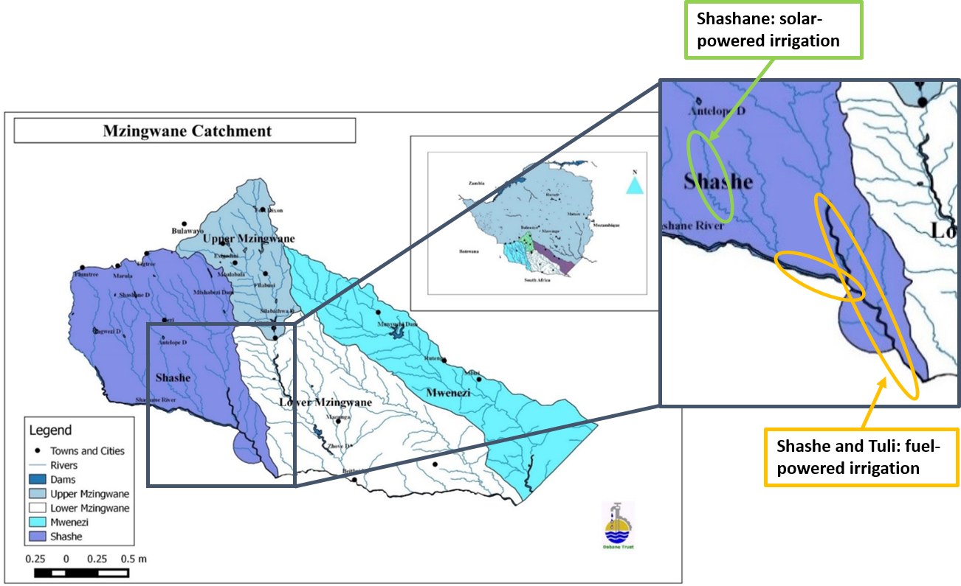
Figure 1 Map of the study area showing the Shashe and Shashani catchment in the Limpopo River Basin.
The Hoff Framework

The WEF nexus framework for the Limpopo River Basin case study is explained in detail in Table 1.
Table 1
Nexus framing | Currently, three irrigation plots using the solar water pumps are expected to increase the irrigated lands in the next decade and ensure water, energy, and food security in the basin. Food security is also expected to be boosted by the increasing activities of small-scale fisheries. The diversification of local food produced available/accessible for consumption is crucial for coping with nutrition issues and livelihood.  Water  - The water is available from the sand rivers which are not far from the irrigation land  - The basin faces the problem of water accessibility  - Although climate change is expected to amplify the natural variability of water, the basin has not experienced water shortages  Energy  - Solar energy is used, replacing previous diesel and petrol pumps  - Maintenance and installation of the solar system is expensive  - Cost, availability and accessibility of solar installation and maintenance is a challenge  Food  - The farmers grow covo/ kale, potatoes, tomatoes, rape, sweet potatoes, corn, carrots, pumpkins, onions, butternuts, watermelons amongst others  - They also keep goats, cows and chickens  - Planning to increase land under irrigation and add more crops  - Start fish farming  Socio-economic  - The land use change might have a considerable impact on increasing outputs hence increase in profits thus improving socio-economic livelihoods of local people.  - The basin is facing challenges specifically for markets availability, cost of transport to the markets,  - Furthermore, the cost of energy (e.g., maintenance and installation) from various sources can have an impact on the socio-economic development  - Controlling of pests and diseases as well as wild animals (e.g., monkeys, foxes etc)  - They project that sand mining could affect their water source  - Security of solar panels i.e. thieves  - People have to travel long distance from home to the field/farm.  - Conflicts between members of the irrigation scheme especially when the group has more than three members  Land availability  While increasing income is generated from the expansion of arable land, the rapid and uncontrolled land use change is undermining other sources of livelihood and is significantly contributing to biodiversity loss and compromising ecosystem health.  Land shortage for expansion  People are clearing land and cutting down trees for fencing the garden  Although the irrigation projects in the Limpopo river basin are expected to have positive impacts in terms of water and food availability and access, irrigated land, food diversification, job creation, income generation, and human and ecosystem health, downsides are also forecasted. Increasing agricultural activities can have an impact in terms of pollution, loss of biodiversity, provision of ecosystem goods and services, land degradation, and soil fertility.
Nexus opportunities | Irrigation is limited (besides water scarcity) by high energy demand and associated cost. In the LRB farmers are replacing fossil fuel with solar energy for pumping irrigation water. The use of solar pumps has the potential to reduce costs for buying fossil energy. Farmers have been travelling for at least 50 km to buy petrol and diesel.  The main activities in the case study are crop irrigation, livestock rearing and fish farming using water from sand rivers. The farmers are using solar energy to pump the water. Solar pumping provides energy- and climate-smart agricultural water supply and supports the shift of the energy system to renewables. With that it contributes to climate change mitigation and it can reduce the cost of irrigation and improve farmers’ income and then their livelihoods.  The easy accessibility to water enhances crop diversification and yield, hence improving food security  Higher yields will lead to higher income; hence farmers can also increase the number of livestock they own.  More livestock will result in more manure which can be used to increase crop yield.  Water-Energy-Food nexus approach can help to analyze the intended outcomes at the basin scale. The WEF nexus analysis will be used to identify the main pillars and sub-pillars involved in the programme. It can also highlight the main interlinkages between them, showing and assessing how a potential decision/s made in a sector may influence other sectors. The analysis can help to identify and quantify potential synergies and trade-offs between key pillars and sub-pillars in the basin and assess different scenarios and management strategies, subsequently providing decision-makers with feasible, sustainable development.  The main expected outcomes of the Limpopo WEF nexus case study are:  Increased water accessibility by installing pumps with bigger pumping capacity  Increased food production through irrigated agriculture (a benefit for a significant number of families);  Increased access to water supply for crop irrigation  Socio-economic improvement of the LRB inhabitants (increased number of people to benefit)  Small-scale fisheries activities to enhance protein intake and provide an alternative source of income to the inhabitants;  Increased water conservation/storage to improve water access during pump failures and cloud cover
Technical and economic nexus solutions | The core of the Programme is to increase the number of solar panels, water pumps  Increase the area under irrigation which the sand rivers will supply water for and that will be beneficial to a significant number of farming families.  The socio-economic system is planned to be boosted by additional crop preservation equipment.  The WEF nexus approach can help to analyse qualitatively and quantitatively the:  - impact of the construction of water pumps in the basin;  - potential increases in irrigation land and crop yields;  - potential increases in food production;  - potential increases in the access to water supply; socio-economic improvements;  - limits to land and water availability  - improved sustainable management of the LRB; and  - expected increases in small scale fisheries activities.
Stakeholders involved | Ministry of Lands, Agriculture, Fisheries, Water and Rural Development has a number of departments playing different roles stated below:  - Agricultural education, agricultural advisory services, -educating the farmers on sustainable agricultural practices such as crop water requirement, cropping season, crop rotation,  - Veterinary services – education and treatment of animal diseases, control of disease outbreaks, animal feeds  - Water Resources Planning and Irrigation Development: - water allocation and protection of surface water quality and quantity  - Parastatals such as ZINWA, are responsible for ensuring the equitable accessibility and efficient use of water resources  NGOS such as Dabane Trust: - It works with vulnerable communal farmers to alleviate poverty and hunger through appropriate and sustainable land use and water management systems.  Academic researchers: -The contribution of the academic community is central in developing sustainable solutions to address water energy and food nexus of the LRB through advancing water sciences, research and knowledge and applying them in the preparation, establishment and testing of the appropriate frameworks and tools that would be needed to address the challenges. This should not only address water, food or energy issues and provide tools to address them together, but also consider the interlinkages of the water, energy and food nexus.  Local farmers; - They know the local context well, and can support and exit the project easily. e
Framework conditions | The solar water pumping irrigation project in the LRB has been implemented at a pilot scale so far. The first pilot was tested on three hectares and three plots of 1 hectare each. This pilot was funded by international organizations such as the European Union. Alignment with national policies, institutions and funding as well as upscaling of the project is underway or planned. The LRB is part of the SADC and the WEF nexus approach is currently at the core of the SADC plans and strategies. Therefore, the upscaling is going to require cooperation between all the stakeholders for easy formulation of policies.  The Zimbabwean government has welcomed the pumping of water from sand rivers using solar water pumps to boost food security and improve livelihoods of local farmers. The government is planning to develop policies that support these small holding irrigations.  The involvement and engagement of local interested stakeholders and experts is critical to achieve on-the-ground impact.
Monitoring, evaluation and next steps | There is a need for a continuous monitoring by all the stakeholders of the water, energy and food pillars in the LRB.  Currently there are three plots using three solar water pumps and this is going to increase in the near future. Only 3 hectares are under irrigation. In the next 5 years the irrigated land, crop production, market and profits are going to increase. Income per household is going to increase significantly.  All the stakeholders are equally important. The LRB assessment is intended to support decision-making, therefore developing short-, medium- and long-term strategies for sustainable integrated resource management in the basin.  The WEF nexus of the LRB can provide a means to assess progress towards relevant SDGs, particularly SDGs 1 (No poverty), 2 (Zero hunger) and 13 (climate action).

